Analog Lab 5:

Darlington Circuits

Date: 2023/04/27

Class: 電機二全英班

Group: Group 8

B103105006 胡庭翊

B103105018劉姵妤

Submitter:

B103105006 胡庭翊

1. Working Project #1: Photoelectric controller
2. Measurement Data
3. By connecting the CdS to the multimeter, and let it face to the light, we can measure and get the resistance of 3.49kΩ.
4. Using finger to cover the resistor, we measured and got the resistance of 18.30kΩ.

Q1: Using finger to cover the CdS, the LED light up.

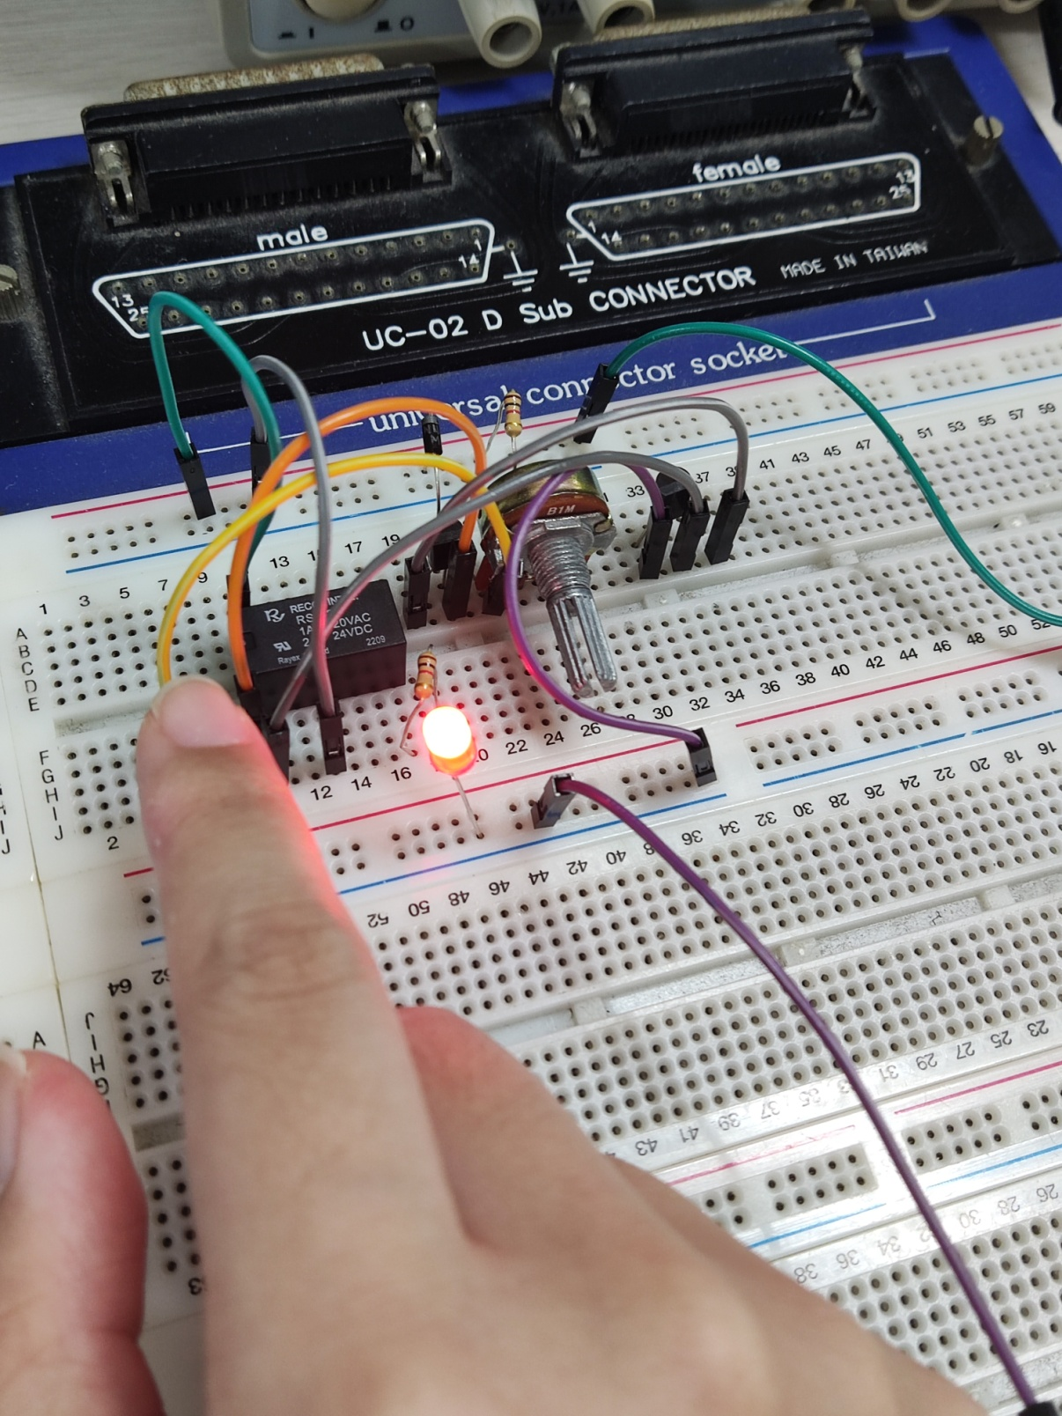

Q2: Removed finger, the LED turned down.

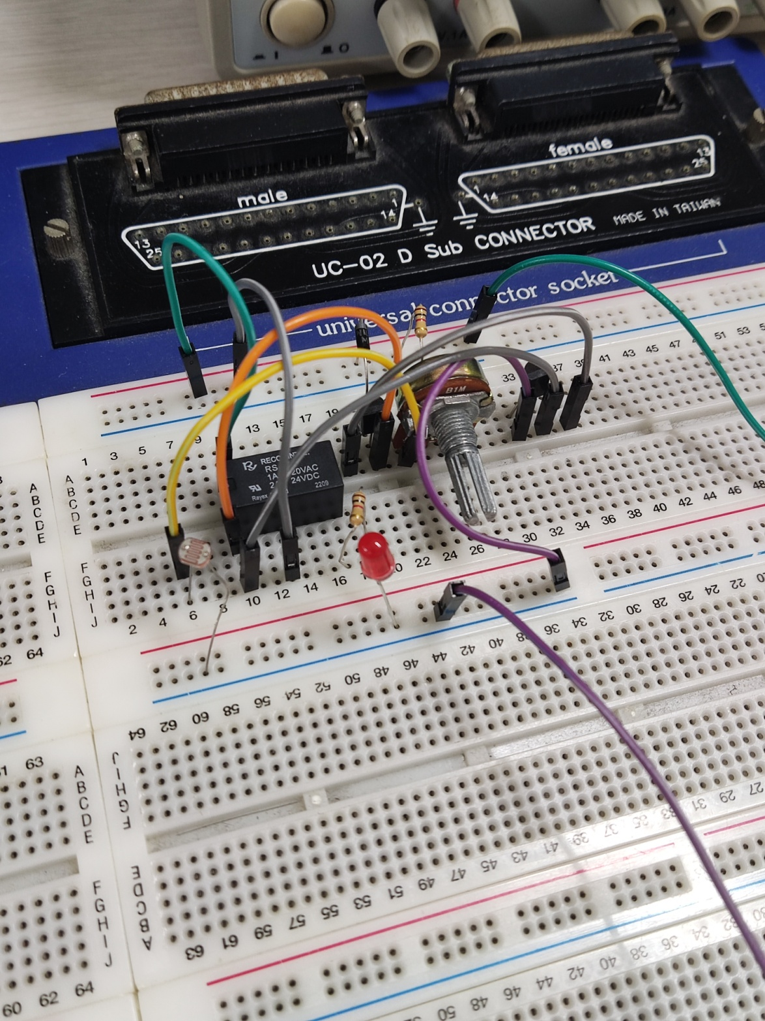

1. Simulation Result
2. Adjust the resistor right until the LED turned off. The edge resistance is 3.368kΩ.

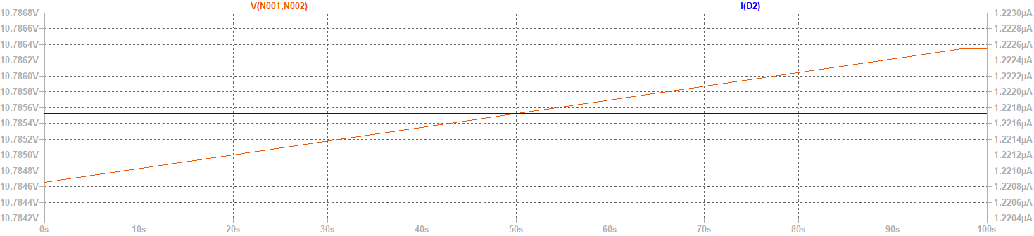

1. Use finger to cover up the CdS, which is, adjust the R5 from the measured value (uncovered: 3.49kΩ to covered: 18.30kΩ), we found the current passing through LED increased and hence the LED lighted up.



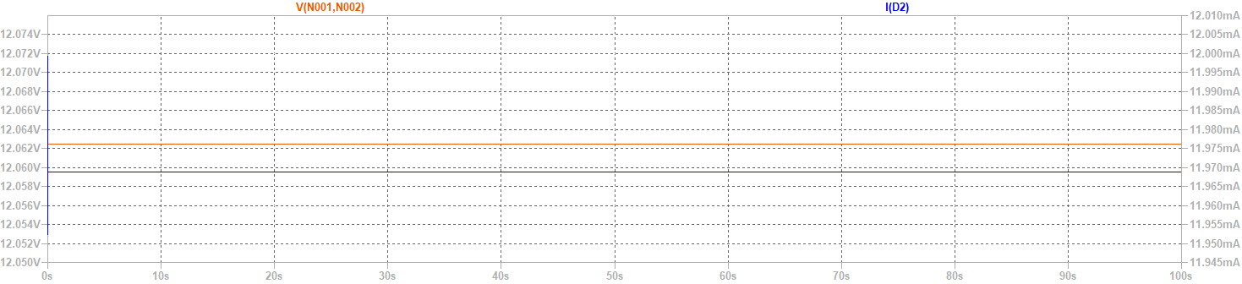

1. The LED turned off (current passing through LED dramatically decreased) again after adjusting the resistance from 18.30kΩ back to 3.49Ω, which as, removing the finger.





1. Observation and discussion

Observation:

In this circuit, the LDR with Darlington amplifying circuit is used to control the electromechanical relay. When the high enough current passes through the coil of the relay, the panel in the relay makes the circuit closed, which makes the LED bright. The LDR shows a high value of resistor when less light exposed on the senor, making the voltage across LDR relatively low, and then the Darlington circuit produced a high current passing through the relay to make the LED bright.

Discussion:

Q: Why in simulation, the input voltage is 12.7V instead of 12V?

A: Since the trigger voltage of the SW is 12V, we measure the voltage across SW1, which is V (N001, N002) and adjust the input voltage from 12V to 12.7V, so as the input voltage into SW1 is , which is the very close voltage that can trigger the SW1 to work, and as the result, it gives the current passing through LED 11.968mA.

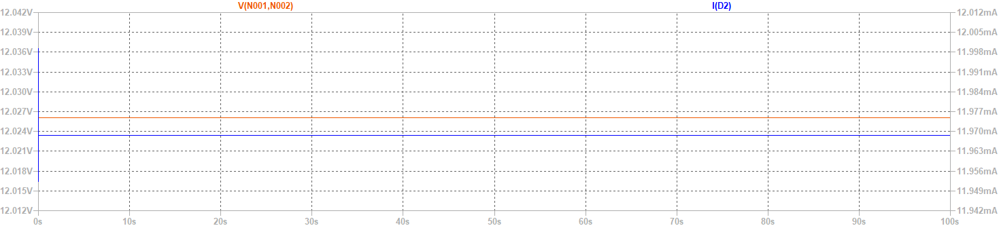

1. Working Project #2:Time Delay Relay
2. Measurement Data

Q1: After turning on the switch for a while, the relay holds and hence the LED lights up.

Q2: After turning off the switch, turn the potentiometer clockwise to the end, and then turned on the switch again, the relay holds for 0 second to light up, which means, we observed that it re-lighted up immediately.

Q3: After turning off the switch, turn the potentiometer counterclockwise to the end, and then turned on the switch again, the relay holds for 15 second to light up.

Q4: Hence we know that the relay can holds at least 0 second and at most 15 seconds.

1. Simulation Result

Q1: After turning on the switch for a while, the relay holds and hence the LED lights up.



The voltage across the diode is V (N001, N002), and the current passing through the diode is I (D1).

Also, V (n001) is the input step voltage of 13V, and V (n008) is the voltage across SW1.

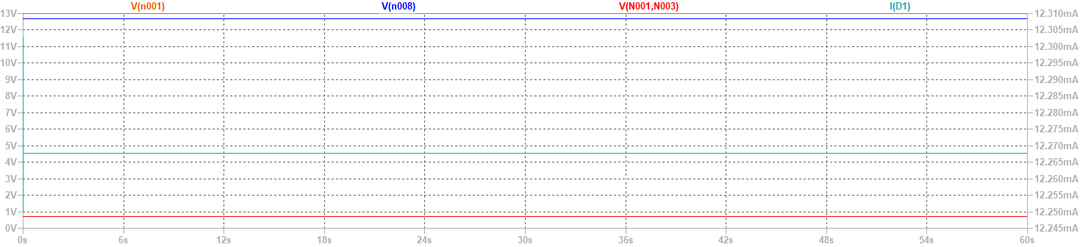

Q2: After turning off the switch, turn the potentiometer clockwise to the end, and then turned on the switch again, the relay holds for 0 second to light up, which means, we observed that it re-lighted up immediately.



V (n001) is the input step voltage of 13V with 1 second delay.

V (n008) is the voltage across SW1, and I (D1) is the current passing through the diode.

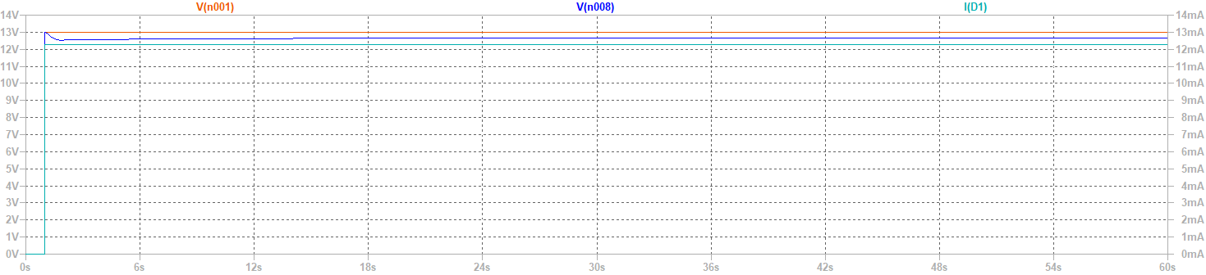

Q3: After turning off the switch, turn the potentiometer counterclockwise to the end, and then turned on the switch again, the relay holds for 30 seconds to light up.



V (n001) is the input step voltage of 13V with 1 second delay.

V (n008) is the voltage across SW1, and I (D1) is the current passing through the diode.

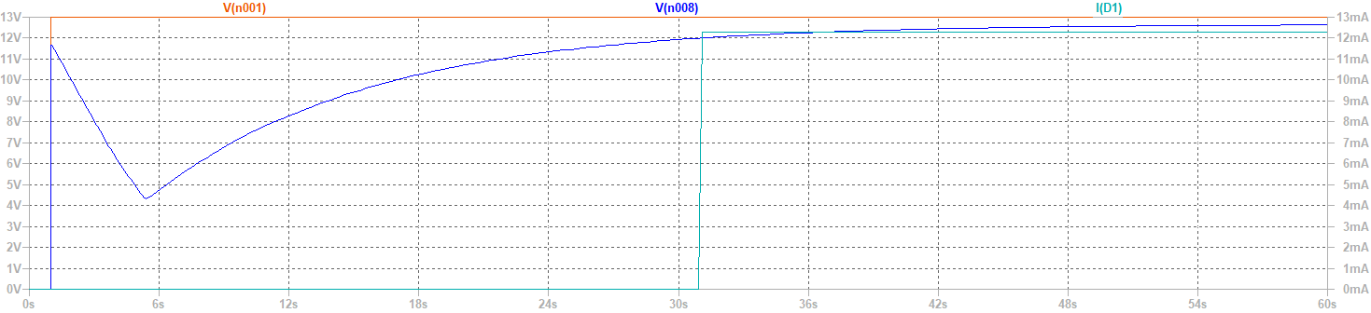

Q4: Hence we know that the relay can holds at least 0 second and at most 30 seconds.

1. Observations and Discussions

Observation:

Time delay relay utilized the same design of Darlington circuit with the previous lab, while the LDR is changed to a capacitor and where the relay is placed. In the characteristic of the capacitor, it takes a short time for the capacitor to charge. After the short period of charging, the capacitor acts like open circuit, driving high voltage across the capacitor to make the relay panel close and light up the LED. Notice that there’s an additional variable resistor in series with the capacitor, which is in charge of the value of current passing through the capacitor. Less current would pass through with high resistance in series, and then more time would be cost to charge the capacitor, leading to a long delay on the LED, vice versa.

Discussion:

Q: Why in simulation, the input voltage is 13V instead of 12V?

A: If we input 12V, the capacitor cannot actually be charged to and give the required trigger voltage 12V to SC1, hence the time delay system cannot function.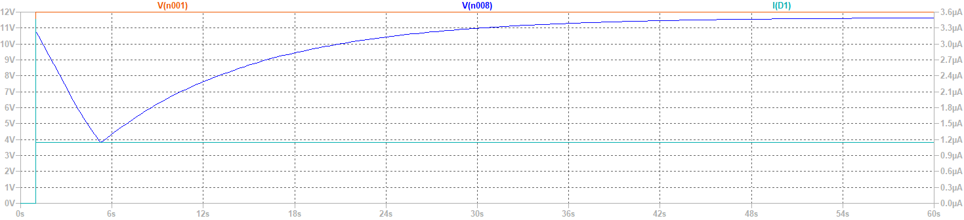

I (D1) is extremely small and the voltage across SC1 cannot meet its trigger voltage.

Q: Why the delay time in simulation differs from practical statistic?

A: The delay time depends on the speed of voltage charge from capacitor, if we given a smaller then 13V but larger then 12V voltage, the delay time, which is the time for voltage across SW1 increased to its trigger voltage, extended.

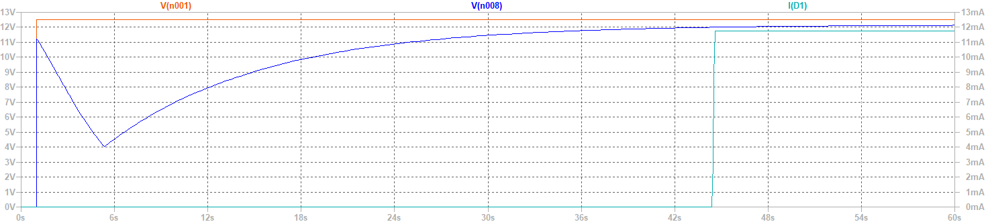

Q: What may also be the factor that can affect the delay time?

A: In the stage of practical measurement, we found that the delay time is extremely short (1 second of delay only). By checking the circuit and components, we found that the β of one of the BJT is un-normally small, which leads to the result that the capacitor charged fast and hence make the delay time short.

1. Practice Problems
2. What’s the Darlington circuit featuring?
   1. The Darlington circuit is able to generate significantly high gain than single one transistor by connecting the two transistors in a unique way.
3. Plot four construction of Darlington circuit.

1. In an auto-control circuit, the electromechanical relays are usually be used with transistors. What’s the advantage of the relay?

The relay is cheap and able to simplify the circuit easily. It’s hard to control the load to be open/ close on the circuit with high value of load current, the relay can control the load close or open with less driving power needed from the transistor.

1. While driving the relay with the transistors, what situation makes the transistors work in the maximum power?
   1. When the voltage across the transistor is same as the one across the relay, which is half of Vcc (=Vcc/2), the transistor would work in max power.
2. Plot a circuit for a temperature controller with thermistor.

1. Reflection

胡庭翊(B103015006):

The first experiment involved a Darlington amplifier circuit and a photoresistor. We used a relay to create a circuit that adjusts the brightness of an LED based on external light levels. The second experiment was on delay relays. We utilized the charging properties of a capacitor to delay the turning on of an LED after it receives power.

During the experiments, we encountered some difficulties. One of the measurements of the circuit turned out to be wrong, and we had to check the circuit for a long time to find out that a transistor was faulty. It was a challenging troubleshooting process, but with the help of the teaching assistant, we eventually resolved the issue.

Overall, I found these experiments to be very interesting and informative. Through these hands-on activities, I learned about the practical applications of electronic circuits. More importantly, I realized the importance of thorough circuit testing and troubleshooting to ensure the correct functioning of the circuits. I appreciate the assistance of the teaching assistant in resolving the issues we faced during the experiments.

劉姵妤(B103015018):

In the first experiment, we built a Darlington amplifier circuit and used a photoresistor to regulate the brightness of an LED through a relay. In the second experiment, we tried a delay relay circuit that introduced a time-lapse before the LED lit up by relying on the capacitor's charging and discharging properties.

Although the experiments were exciting, they were not without their challenges. One of the biggest obstacles we faced was when our circuit measurements returned inaccurate results. It took a while to troubleshoot, but eventually, we discovered that a malfunctioning transistor was the cause of the problem. We quickly replaced the component and continued with the experiment.

Overall, the experiments were a fantastic opportunity to apply our theoretical understanding of electronics to practical applications. We appreciated the chance to build the circuits from scratch and troubleshoot issues that arose along the way. We were grateful to have a supportive teaching assistant who provided valuable guidance during the troubleshooting process and helped us solve the transistor issue.

In conclusion, we enjoyed the experience of working on these two experiments, and we learned a great deal from them. We look forward to future classes where we can continue to apply and expand our knowledge of electronic circuits and their applications.